SANGAMNER NAGARPALIKA ARTS, D.J. MALPANI COMMERCE & B.N. SARDA SCIENCE COLLGE, SANGAMNER, DIST. AHMEDNAGAR-422 605
Department of Botany
EXCURTION REPORT – 2012-2013
Name of Student:…………………………………….. Seat No:………………………
Organized by : Department of Botany
Date : 19 & 20 December 2012
Class : S.Y.BSc.
Tour Incharge : Prof. Divekar M.V
: Prof. Navale MB
Escort : : Mr Kedar S.M
Route Sangamner- Tamni Ghat- Harihareshwar - Shiriwardhan –Dapoli- Harne Beach; Kokan Agriculture University -Pali- Mahad Sangamner
Kind of Journey : Private Bus.
Place Visited : : Tamani Ghat Florestic study
Konkan Agriculture University Biofertiliser Prodution unit and (Nursery and Polyhouse)

At early morning 04.30 Am, we started the journey from Sangamner to towards Pune (Tamani Ghat ) with the objective to visit Florestic study and collection of Angiosperm plant,, Due to the academic fulfillment, it was included as a part of our syllabus And at the Evening we rich at Harihareshwar Beach for zoological collection .Next day we start early morning to visit Murud Beach .Afternoon we visit to Dapoli Agriculture university for Biofertiliser production unit Where we met Dr. Mule Head of Department (Biofertiliser ,Polyhouse Greenhouse ) It was the Best unit for production of different Biofertiliser like Rhizobium Azotobacter BGA Phosphate solubilizer Head of the Institute and gave detailed account us about the Institute and its details. Polyhouse and greenhouse, especially different method of plant propagation and jerbera plantation. They willingly gave us the information about lots of Plant.. After we visit to Holy places-Pali & Mahadi and we completed our journey at Next day at 05.30Am.
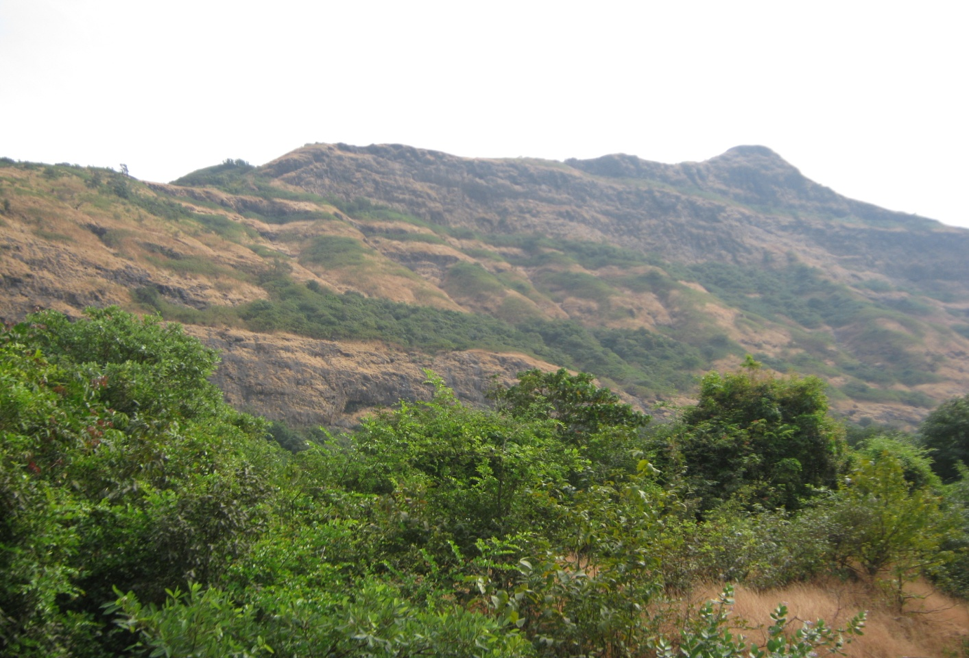

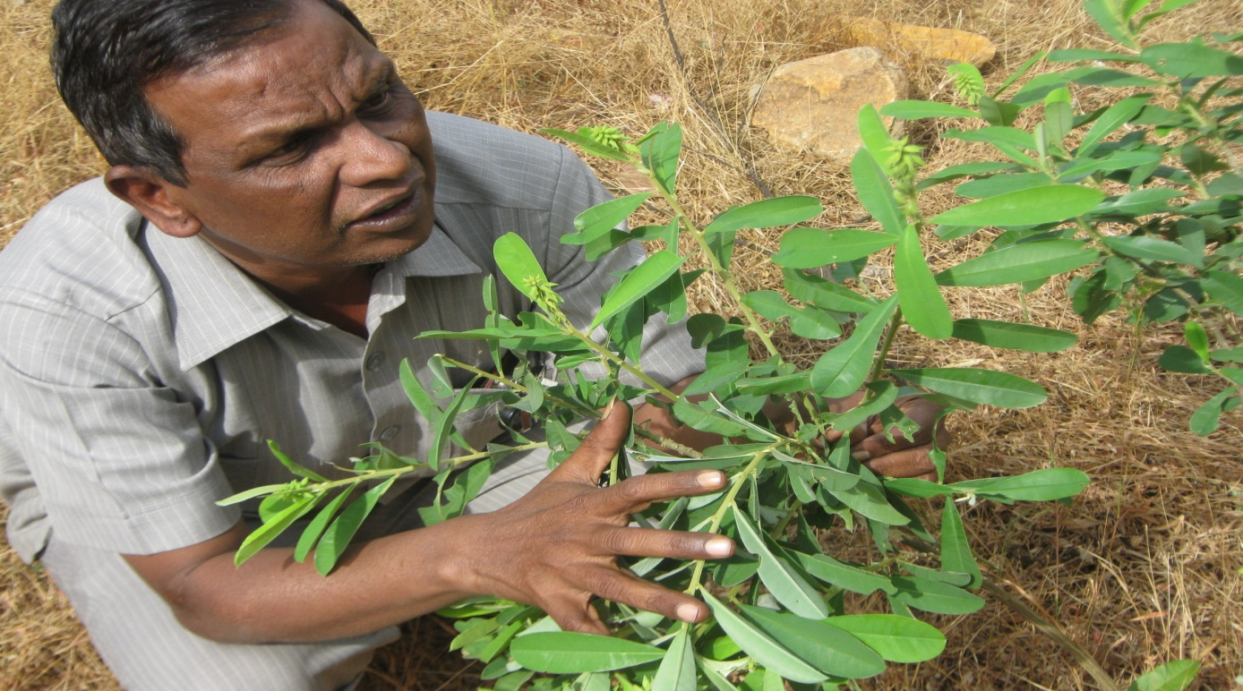

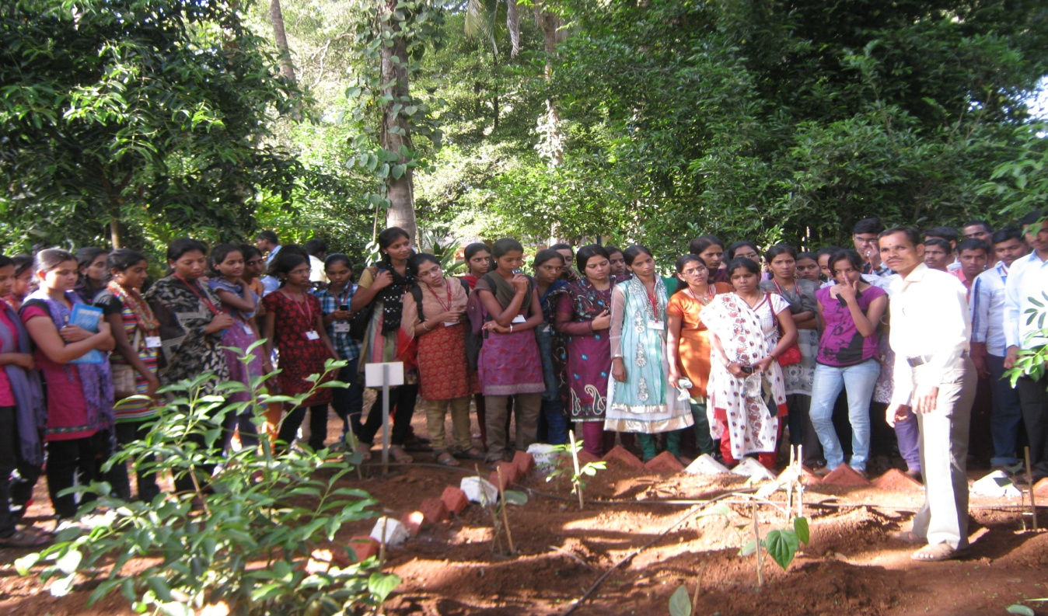

Department of Botany
PHOTO HERBARIUM PLATE

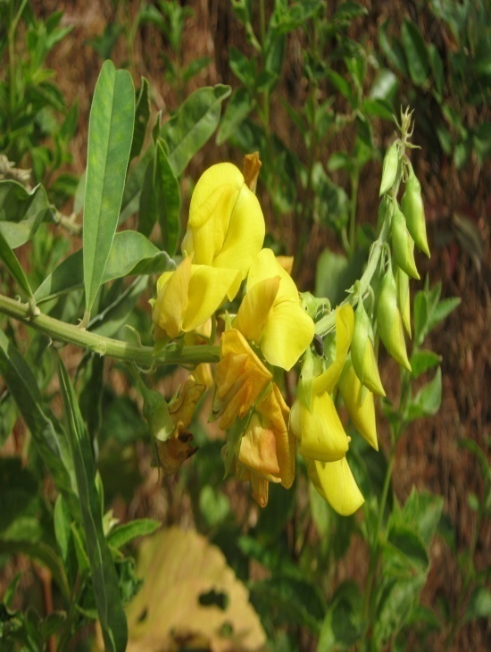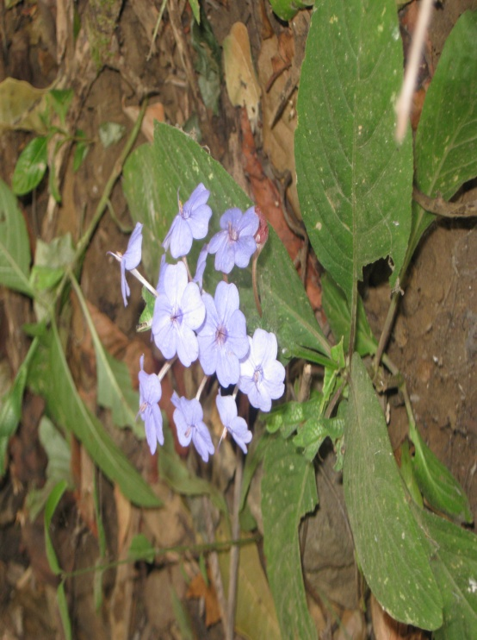

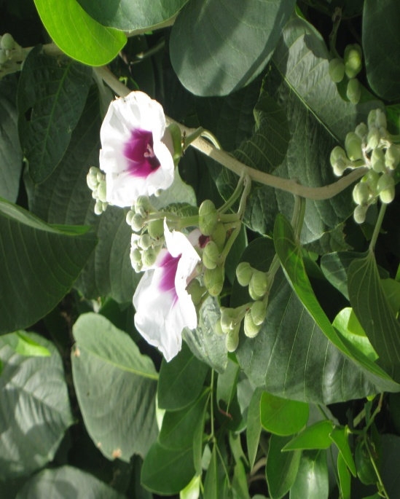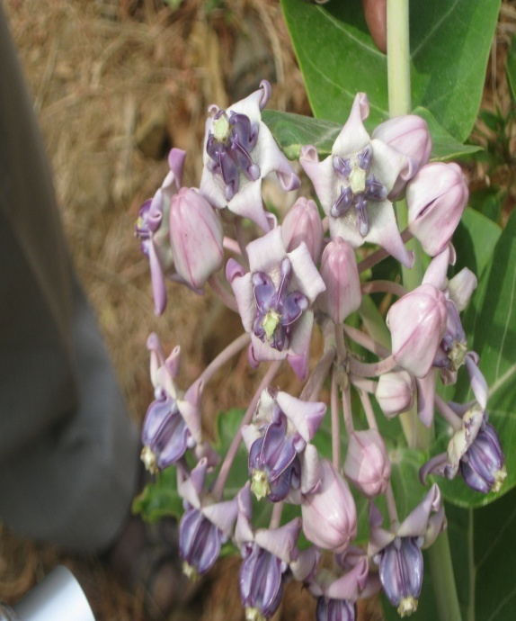

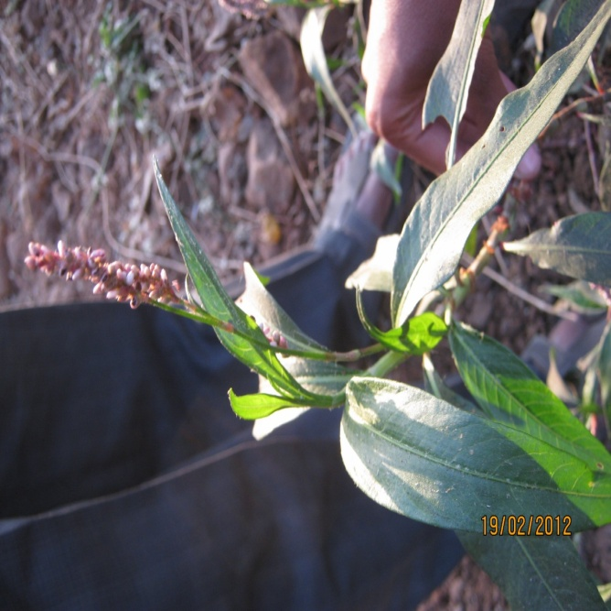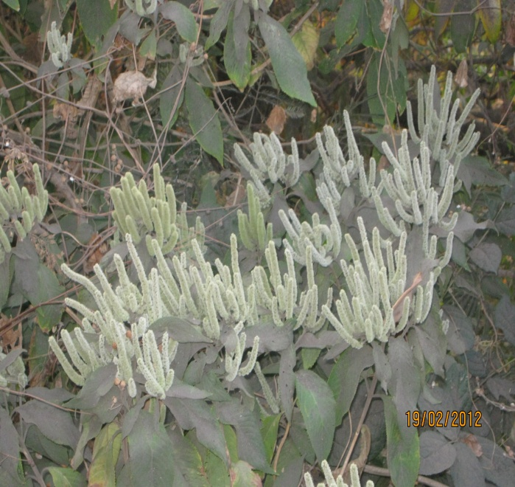
Colebrokea oppositiflolia Polygonum glabrum
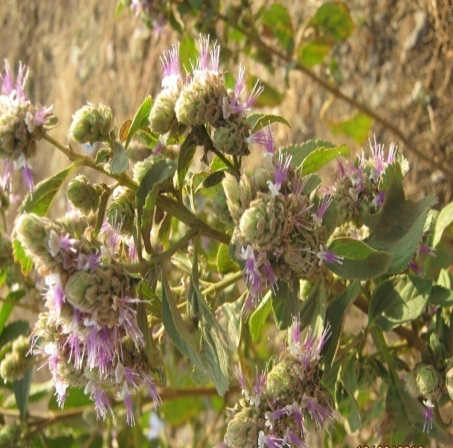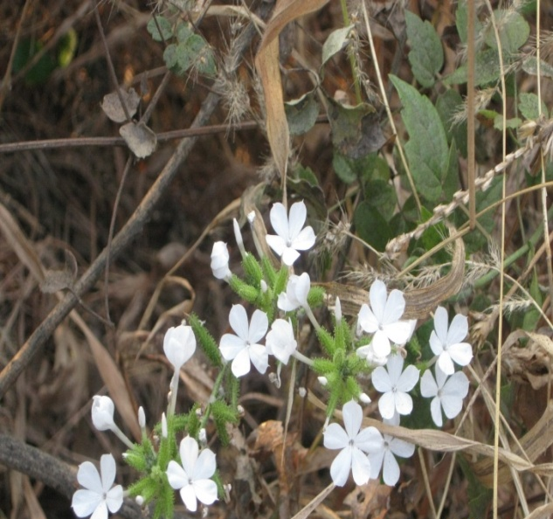
Pogostemo parviflorus Plambago zylenica

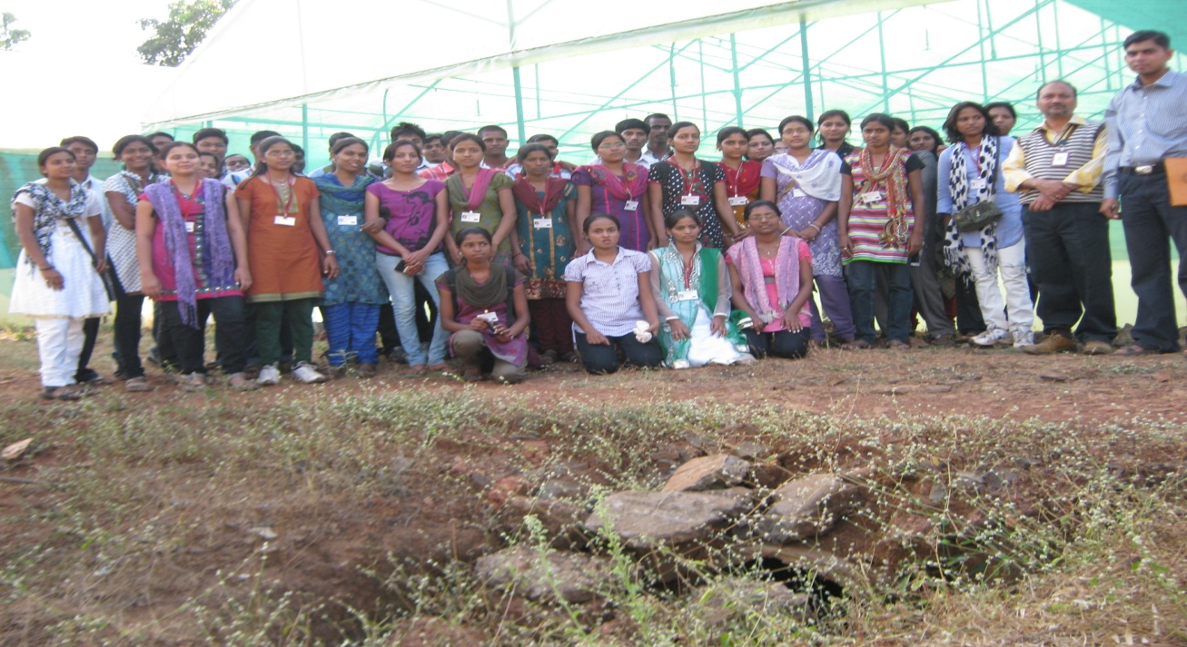

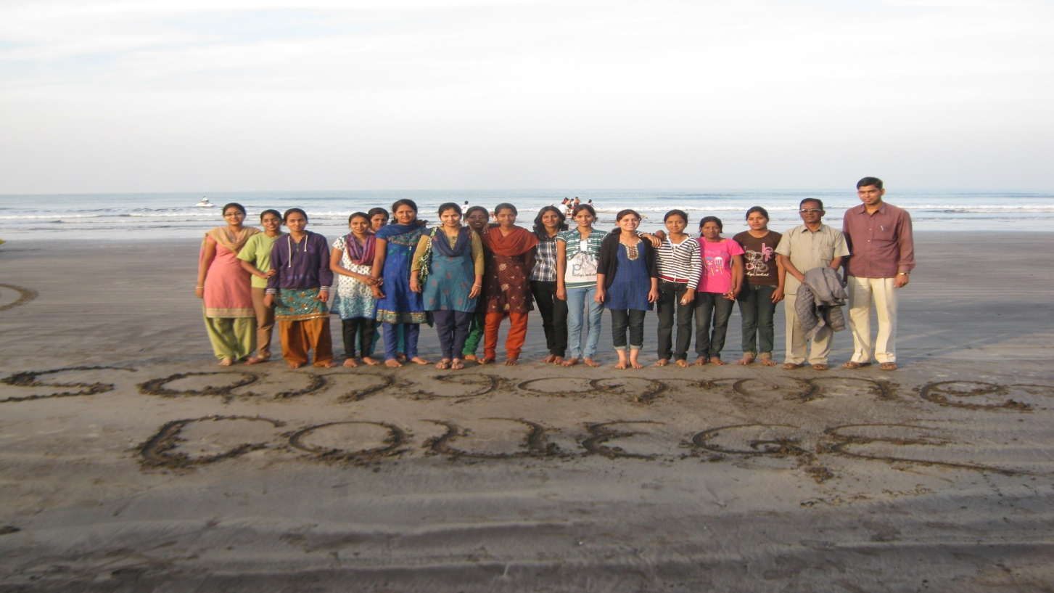

Navale M.B

